**Assignment 1: Create an infographic illustrating the Test-Driven Development (TDD) process. Highlight steps like writing tests before code, benefits such as bug reduction, and how it fosters software reliability.**

**Test-Driven Development (TDD) process :**Test-Driven Development (TDD) is a software development process where test cases are written before the actual code implementation. It relies on short development cycles, repeating a sequence of writing tests, implementing code to pass those tests, and then refactoring. TDD utilizes automated unit tests to drive the design and ensure decoupling of dependencies. By writing tests first, developers clarify requirements and design, leading to more modular and maintainable code.

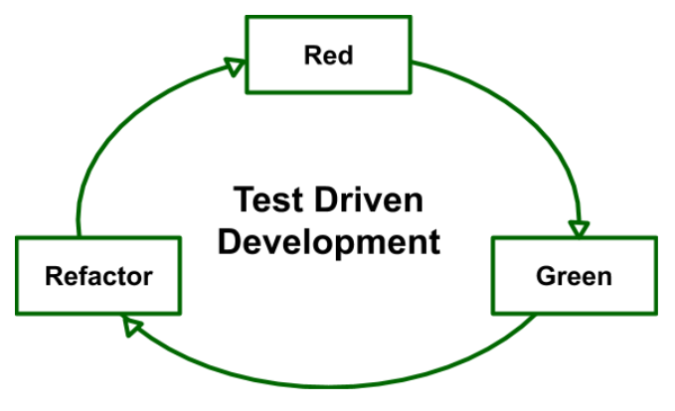

**Sequence of steps followed for TDD :**

1. Write a failing test that defines the desired behavior.
2. Write the minimum code necessary to make the test pass.
3. Refactor the code to improve its structure without changing its behavior.
4. Repeat the process for the next desired behavior or functionality.

**Benefits of using TDD :**

1. TDD helps in identifying bugs at an early stage of development, reducing the cost and effort required for debugging later in the process.
2. TDD encourages writing modular, well-structured code, leading to better code quality and easier maintenance.
3. TDD ensures that all parts of the codebase are covered by automated tests, providing a safety net for future changes and enhancements.
4. By writing tests before writing code, TDD promotes clearer understanding of requirements and better design decisions.
5. TDD shortens the feedback loop by quickly identifying failures and allowing developers to address issues immediately, resulting in faster development cycles.

**TDD fosters software reliability due to :**

1. Continuous Validation
2. Early Detection of Defects
3. Incremental Development
4. Regression Testing
5. Clearer Specifications

**Assignment 2 : Produce a comparative infographic of TDD, BDD, and FDD methodologies. Illustrate their unique approaches, benefits, and suitability for different software development contexts. Use visuals to enhance understanding.**

**Test-Driven Development (TDD) :**  
Test-driven development (TDD) is a software development approach where tests are written before the code. . It relies on short development cycles, repeating a sequence of writing tests, implementing code to pass those tests, and then refactoring.



**The process typically follows a cycle of Red-Green-Refactor:**

* **Red**: Write a failing test. This test should initially fail because the feature it's testing hasn't been implemented yet.
* **Green**: Write the minimum amount of code necessary to pass the test. This code might not be perfect or optimized, but it should make the test pass.
* **Refactor**: Refactor the code to improve its design, readability, and performance while ensuring that all tests still pass.

**Unique Approaches:**

* **Incremental Development:** TDD encourages incremental development by focusing on writing small, testable units of code. This helps in building the software gradually and ensures that each component works as expected before moving on to the next.
* **Continuous Feedback Loop:** TDD provides developers with immediate feedback on their code. If a change breaks existing functionality, it's caught right away, allowing for quick identification and resolution of issues.
* **Documentation through Tests:** Tests serve as living documentation for the codebase. They describe the expected behavior of the system and provide insight into its design and functionality.

**Benefits of using TDD :**

* TDD helps in identifying bugs at an early stage of development, reducing the cost and effort required for debugging later in the process.
* TDD encourages writing modular, well-structured code, leading to better code quality and easier maintenance.
* TDD ensures that all parts of the codebase are covered by automated tests, providing a safety net for future changes and enhancements.
* By writing tests before writing code, TDD promotes clearer understanding of requirements and better design decisions.
* TDD shortens the feedback loop by quickly identifying failures and allowing developers to address issues immediately, resulting in faster development cycles.

**Suitability for Different Software Development:**

* Complex Systems
* Critical Systems
* Agile Development

**Behavior-Driven Development (BDD) :**Behavior-Driven Development (BDD) extends Test-Driven Development (TDD) by focusing on how the software behaves according to the needs and expectations of everyone involved, including developers, testers, and business users. It promotes collaboration among these parties to ensure that the software meets the desired outcomes.

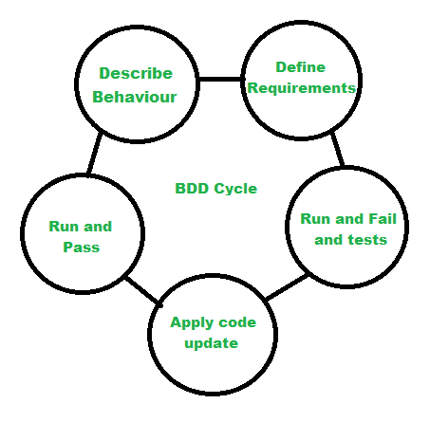

**Unique Approaches:**

* **Shared Understanding:** BDD encourages collaboration between technical and non-technical stakeholders to create a shared understanding of the system's behavior. This helps ensure that the software meets the requirements and expectations of all parties involved.
* **Natural Language Specification:** Tests in BDD are written in a natural language format that can be easily understood by stakeholders who may not have technical expertise. This allows for better communication and alignment between different roles within the team.
* **Focus on User Stories:** BDD typically starts with defining user stories or features from the perspective of end-users. Tests are then written to validate these user stories, ensuring that the software behaves as expected from the user's point of view.

**Benefits of using BDD :**

* BDD enhances communication and collaboration among team members by establishing a shared language for discussing requirements and behavior, reducing misunderstandings and ensuring alignment.
* By expressing tests in a natural language format, BDD clarifies and formalizes requirements, making it easier to validate that the software meets desired behaviors and outcomes.
* BDD encourages active participation of business stakeholders throughout the development process by presenting tests in a language they understand, facilitating their involvement in defining and validating requirements.
* By focusing on validating the behavior of the system from the user's perspective, BDD ensures that development efforts are aligned with user needs and expectations, ultimately delivering value to the business.

**Suitability for Different Software Development:**

* Collaborative Environments
* User-Centric Applications
* Agile Development
* Legacy Systems

**Feature-Driven Development (FDD) :**Feature-Driven Development (FDD) is an iterative and incremental software development methodology that focuses on delivering features incrementally. It emphasizes building software around features or functionalities, with a focus on designing and implementing features one at a time.

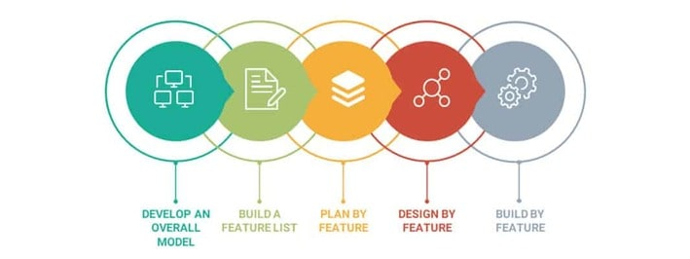

**Unique Approaches:**

* Feature-Centric: FDD organizes development around features, which are chunks of functionality that deliver business value. Each feature is developed separately, from design to implementation, allowing for a clear focus on individual functionalities.
* Modeling: FDD utilizes modeling techniques, such as domain object modeling and feature modeling, to understand and represent the problem domain. Models help in visualizing the system's structure and behavior, aiding in the design and development process.
* Iterative and Incremental: FDD follows an iterative and incremental approach to development, where features are built and delivered incrementally in short iterations. This allows for regular feedback and early delivery of valuable functionality.

**Benefits:**

* FDD provides a clear focus on features, allowing teams to prioritize and develop functionalities that deliver the most value to the business. By breaking down the development process into manageable features, FDD helps in managing complexity and scope.
* FDD emphasizes delivering working software incrementally and iteratively.
* By delivering features incrementally and validating them early, FDD helps in mitigating risks associated with large-scale software development.

**Suitability for Different Software Development:**

* Large-Scale Projects
* Client-Focused Development
* Projects with Evolving Requirements
* Team Collaboration